G.R.A.P.E.S.
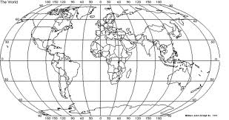 | Geography (5 Themes)  - Location  - Place  - Movement  - Regions  - Human & Environment Interaction
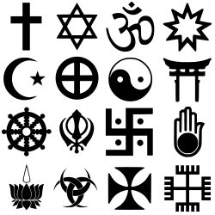 | Religion  - Monotheistic or Polytheistic  - gods, goddesses, God  - Beliefs about Creation, Life, Death  - Practices  - Myths and Other Texts
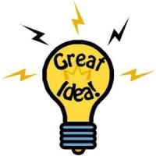 | Achievements  - Language & Literature  - Arts & Music  - Math  - Science  - Architecture  - Technology
Politics
- Types of Government
- Rights & Laws
- Leaders
- War
- Peace
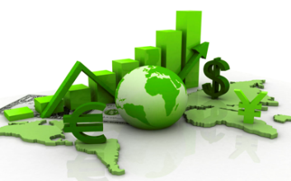 | Economic$  - Surplus  - Specialized Jobs  - Greed  - Resources  - Products  - Barter  - Export  - Import  - Currency  - Taxes
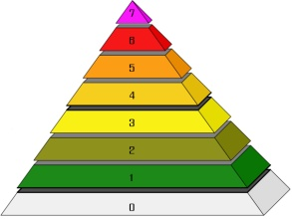 | Social Structures  - Social Classes  - Status & Power  - Roles for Girls, Boys, Men & Women  - Family Structures  - Educational Systems  - Opportunities to Move up in Society

