[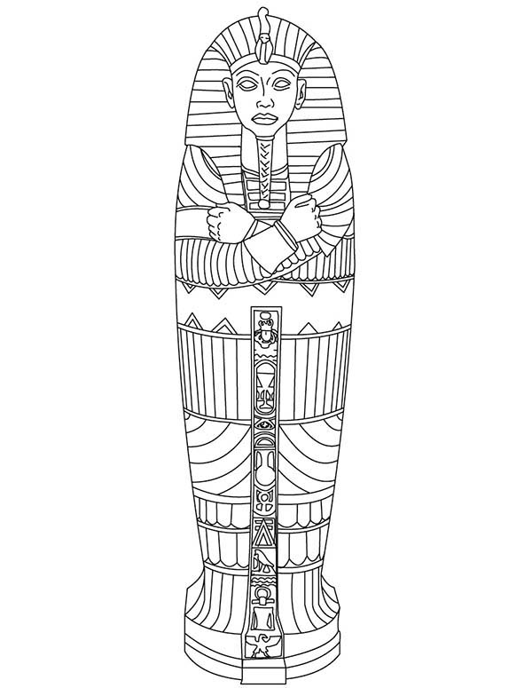](,)

For p _____ of the INB.

1. Cut out the sarcophagus & the tab.

2. Trace the sarcophagus on the page.

3. Fold the tab over & glue just the tab down.

4. Within the traced area, write the steps to creating a mummy.

5. When finished, the sarcophagus lid should open revealing the steps to making a mummy.

6. Give it some color

7. Draw a mummy to fit into the sarcophagus.

Tab to glue down. Cut on dotted line & glue only the tab to the page… like a hinge.