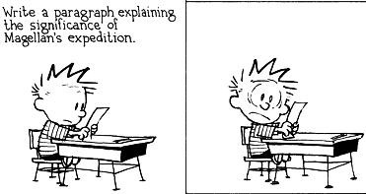
YOUR’E INVITED to PASS YOUR SOCIAL STUDIES MIDTERM!
WHO: YOU
WHAT: Midterm Exam
WHERE: Room 240 MMS
WHEN: February 12, 2014
WHY: To help you learn how to prepare & successfully pass 6th grade SS…. & other cumulative tests.
HOW: This may be the first time you have had to take a midterm, so let’s make sure you know exactly what you need to do.
- Study over a period of time, not all at one time. Your brain will remember more if you study for 10 minutes a day for 6 days than if you study for one day for 60 minutes. Space it out & give your brain a chance.
- VOCABULARY: Make flashcards for yourself. (On SpellingCity.com they are already there, you just need to print them out.) Go through all the cards. Make 2 piles. The ones you KNOW & the ones you DON’T KNOW. Study the ones you DON’T know. As you learn them add them to the KNOW pile. You will find that watching the KNOW pile grow will make you feel really good!
- GEOGRAPHY: Get a few blank maps (like the ones we use in our INB) & see what you can fill in. Practice learning only the areas you DO NOT know.
- TIMELINES: Create a timeline from 4.6 billion years ago to 1BCE. Go through your INB & place on the timeline the major events we have covered. Do not be worried about actual dates. Know that the creation of the earth came before the Stone Age & the Bronze Age was after the Stone Age. Ask yourself what important things occurred during each period of time.
TOPICS to be COVERED on the EXAM
You will be tested on material from September – January.
- Vocabulary: Use your text book & Spelling City.com to help. Refer to the lists in your INB on pages:10, 11, 18, 19,30, 31, 56, 57, 58 & 59.
- Maps – be able to:
  - geographic items (INB p 10 # 1 – 16)
  - Scale (INB p.16 & 17)
  - Mesopotamia
  - Egypt
  - Use INB pages 1 – approximately p. 75
  - Use Textbook pages: 3 – 31, 42 – 51, 102-117, 64 -101

