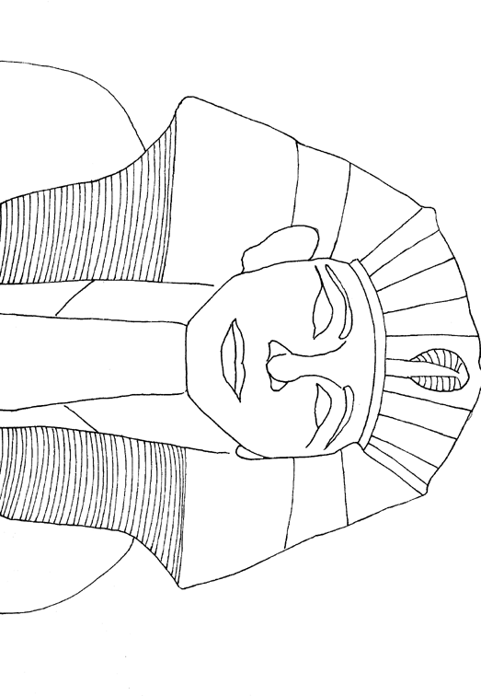

✂ Cut this KWL Chart out. using a bulleted list, fill out the KNOW & WANT TO KNOW. Glue it into the INB on page _55_. You'll fill out the LEARNED after the unit is finished. NOTE P. 54 WILL BE BLANK

LEARNED

WANT TO KNOW

KNOW