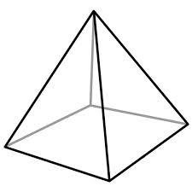
The Power of the Pyramid
The ancient Egyptian people were grouped in a hierarchical system with the Pharaoh at the top & farmers & slaves at the bottom. The groups of people nearest the top of society were the richest & most powerful. The people at the bottom of the 6 levels had the least amount of power.

On page __&___ of your INB, create a Social Pyramid. Draw the pyramid so that it is centered & covers the whole page. Cut & arrange the members of society at the correct level of society at which they would have been found. Check your work & glue them down. | 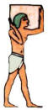  There were no slave markets or auctions in Ancient Egypt. Slaves were usually prisoners captured in war. Slaves could be found in the households of the Pharaoh & nobles, working in mines & quarries & also in temples
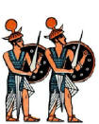  Soldiers were responsible for the defense of the country. Many second sons, including those of the Pharaoh often chose to join the army. Soldiers were allowed to share riches captured from enemies & were also rewarded with l& for their service to the country. | 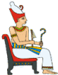  The Pharaoh was believed to be a God on earth & had the most power. He was responsible for making laws & keeping order, ensuring that Egypt was not attacked or invaded by enemies & for keeping the Gods happy so that the Nile f+looded & there was a good harvest.
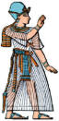  Priests were responsible for keeping the Gods happy. They did not preach to people but spent their time performing rituals & ceremonies to the God of their temple. | 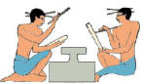  Scribes were the only people who could read & write & were responsible for keeping records. The ancient Egyptians recorded things such as how much food was produced at harvest time, how many soldiers were in the army, numbers of workers & the number of gifts given to the Gods.
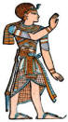  The Vizier was the Pharaoh's chief advisor & was sometimes also the High Priest. He was responsible for overseeing administration & all official documents had to have his seal of approval. He was also responsible for the supply of food, settling disputes between nobles & the running & protection of the Pharaoh's household. | 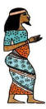  Nobles ruled the regions of Egypt (Nomes). They were responsible for making local laws & keeping order in their region.
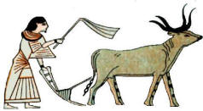  Farmers worked the land of the Pharaoh & nobles & were given housing, food & clothes in return. Some farmers rented land from nobles & had to pay a percentage of their crop as their rent. | 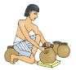  Craftsmen were skilled workers such as - pottery makers, leatherworkers, sculptors, painters, weavers, jewelers makers, shoe makers, tailors. Groups of craftsmen often worked together in workshops.

