Name __________________________ Date __________________________
Subject: CORNELL NOTE TAKING Class Period_____________________
There is no one right way to take notes in class. One effective note-taking system is called The Cornell System.
Divide the paper into three sections.  - Draw a dark horizontal line about 5 or 6 lines from the bottom. Use a heavy magic marker to draw the line so that it is clear.  - Draw a dark vertical line about 2 inches from the left side of the paper from the top to the horizontal line. | 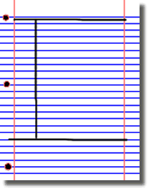
Document  - Write course name, date, and topic at the top of each page. | 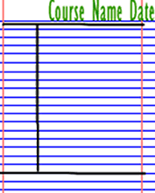
Note-Taking Area  The space to the right of the vertical margin is where you actually record your notes during the lecture. Pick a note-taking format with which you are comfortable -- there are no hard-and-fast rules for this aspect of the Cornell system. However, you should not attempt to transcribe verbatim every word spoken by the instructor. It is usually not difficult to separate the essential material from the non-essential. For instance, if information is written on the blackboard, it is probably important enough to include in your notes. To avoid missing information during the lecture, you should develop a system of abbreviations you understand, and you should write in telegraphic sentences (where you only include enough words to carry the essential meaning) or similar shorthand that is often used in cell phone text messages. As you take notes, realize that your emphasis should be on the key ideas, rather than the actual words used to convey those ideas. | 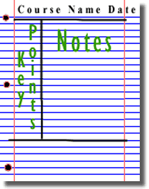
Review & Clarify Column  The space to the left of the vertical margin should be reserved for a reviewing & clarifying. You should not write in this area during the lecture, while you are taking notes. This column is not written in until you review your notes (which, ideally, you do as soon after the lecture as possible, and certainly before the next lecture). As you study the material in your notes, you should devise questions which the notes answer (think "Jeopardy"). These questions are the "cues" that should be written in this column. By writing questions, you are forced to think about the lecture material in a way that clarifies meaning, reveals relationships, establishes continuity, strengthens memory, and attempts to predict test and exam items.  - Review the notes as soon as possible after class.  - Pull out main ideas, key points, dates, and people, and write these in the left column. | 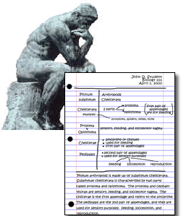
Summarize - Write a summary of the main ideas in the bottom section.  The area below the horizontal margin near the bottom of the page should be reserved for a summary of the notes on that page. A summary is brief -- at most, only a few sentences. The page summary provides a concise review of the important material on the page. More importantly, in writing a summary, you are forced to view the material in a way that allows you to see how it all fits together, in a general sense. The summary should be written in your own words... helping you to own the information. | 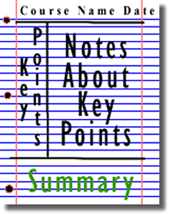
Study your notes.  - Re-read your notes in the right column.  - Spend most of your time studying the ideas in the left column and the summary at the bottom. These are the most important ideas and will probably include most of the information that you will be tested on | 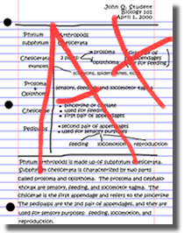
Info for this document came from http://coe.jmu.edu/learningtoolbox/cornellnotes.html & http://www.montgomerycollege.edu/Departments/enreadtp/Cornell.html
- You can create Cornell Note Taking paper @: http://www.cornell-notes.com/

