Name __________________________ Date __________________________
Subject _________________________ Class Period_____________________
Latitude & Longitude: Using the map below, find the locations listed. If coordinates are listed, write the name of the city. If a city is listed, write the coordinates where it can be found. Try to be as close to accurate as possible.
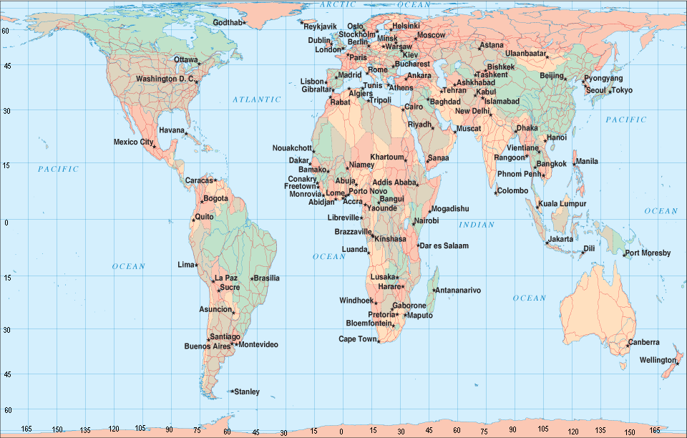
- _________________ Mexico City, Mexico  - _________________ Canberra, Australia  - _________________ 14⁰N, 17⁰W  - _________________ Mogadishu, Somalia  - _________________ 30⁰N, 31⁰E  - _________________ 45⁰N, 75⁰W  - _________________ Kuala Lumpur, Malaysia  - _________________ 33⁰S, 70⁰W  - _________________ 6⁰S, 39⁰E  - _________________ Ulaanbaatar, Mongolia | - _________________ 16⁰S, 48⁰W  - _________________ Tokyo, Japan  - _________________ 6⁰S, 106⁰E  - _________________ Havana, Cuba  - _________________ Wellington, New Zealand  - _________________ 41⁰N, 12⁰E  - _________________ 38⁰N, 9⁰W  - _________________ Baghdad, Iraq  - _________________ New Delhi, India  - _________________ 64⁰N, 51⁰W

