Name ________________________ Period ______________________

MID YEAR REVIEW
Your midterm is Feb 12. This is a review that should help you prepare. If you can complete this without looking anything up, then you are in good shape. If you need to look something up, then that tells you that you need to review this topic more.

On the map below label the items listed below.
- 7 continents  - 5 oceans  - Equator  - Prime Meridian | - Tropic of Capricorn  - Tropic of Cancer  - North Pole  - South Pole | - The 3 climate zones (polar, temperate, tropical)  - Italian Alps (Location of Őtzi)  - United States  - New York

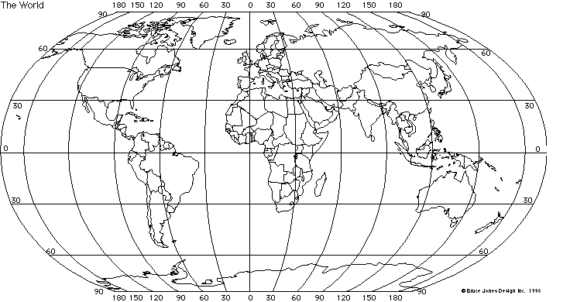

This map is missing 4 things that every good map should have. List those 4 things.
_______________________________________________________________________________________

_______________________________________________________________________________________

Put the following sets of events in the order they happened, oldest to most current.

- 2013 CE  - 2013 BCE  - 1975 AD  - 1975 BC  - Jesus Born | - Necropolis at Giza Constructed  - Cave Art at Lascaux Painted  - Domestication of Animals  - Hunter-Gatherers roam Africa & parts of Eurasia  - Universe Created
- 1000 AD  - 1000 BCE  - Birth of Jesus  - 1001 CE  - 1001BC | - Beginning of Mesopotamian Civilizations  - Creation of the Earth  - Paleozoic Age  - Creation of the Universe  - Bronze Age

Every culture has a creation myth. Explain what a creation myth is & what the purpose of a creation myth is.
_____________________________________________________________________________________
_____________________________________________________________________________________
_____________________________________________________________________________________
_____________________________________________________________________________________

In order to understand a culture, an archaeologist asks a set of questions. Give at least one an example of each of the following.
History: (Example:) The culture is improving. The people's lives overall have improved. The culture has developed new tools that make their lives easier.

Geography:

Economics:

Religion & Philosophy:

Language, Education & Arts:

Government:

Sociology:

WHERE THE ECK AM I? Fill in the blanks.

There are ___________ planets in our solar system. The planets in order from the sun are:
____________________, ___________________, __________________, ________________,
____________________, ___________________, __________________ & ______________.
I live on the ___________ planet, Earth.
Earth is divided into _____________ continents. The continents are: _______________, ____________________, ___________________, __________________, ________________,
____________________ & ___________________. I live on the continent of _____________ __________________.
Continents are divided into _____________. There are 196 _______________ in the world. My continent is divided into 3 ____________________. These 3 are ________________, ________________________________ & ________________________________. I live in the ___________________________________________.
The capital of the country I live in is _____________________________. My country, the _____________________________, is divided into ______ states. I live in the state of _____________________. The capital of my state is ___________________.
My state is further divided into 62 counties. I live in the county of __________________. My county, ______________County, is divided into 9 towns/villages. These 9 towns/villages are: Brewster, Carmel, Cold Spring, Kent, Nelsonville, Patterson, Philipstown, Putnam Valley, and Southeast. I live in ______________. My town, ____________, is divided into 10 hamlets.
- Carmel -- Hamlet of Carmel  - Carmel Hills  - Field Corners  - Hopkins Corners  - Mahopac - where the town government is located | - Mahopac Point  - Mahopac Falls  - Secor Corners  - Tilly Foster  - West Mahopac
I live in the hamlet of ___________________ on a road called _________________________.
If someone wanted to mail me a letter they would address it as follows:
_____________________________________________________________
_____________________________________________________________
_____________________________________________________________

This globe show lines of  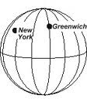 | This globe show lines of  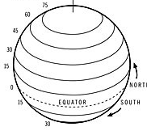

Explain what SCALE is & give at least 2 of the 3 examples of how we have used it this year. ____________________________________________________________________________________________________________________________________________________________________________________
__________________________________________________________________________________________

- The following picture is a ______________________.  - Fill in the missing directions.  - The 4 main directions are called _________________  ________________________________________.  - The other 4 directions are called _________________  __________________________________________. | 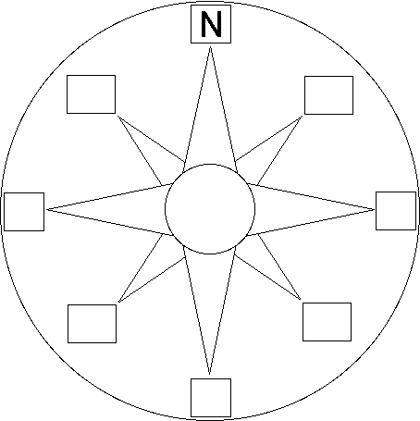

Use your knowledge of the Necropolis of Giza to answer the following questions.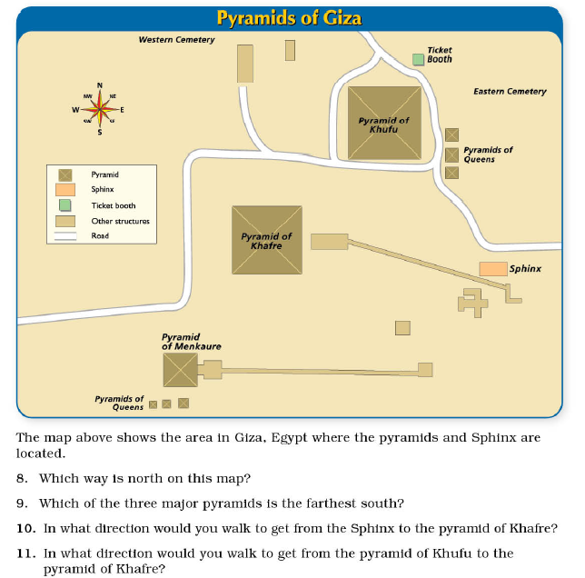
1

2
3

4

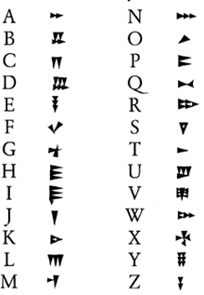 | This is an example of writing called ____________________________________ . It was invented by a culture called the ______________________________. These people lived in what was known as _______________________________. Today this area is known as __________________________________. Two rivers that flow through this area are the _______________________________ and the _____________________________________________.

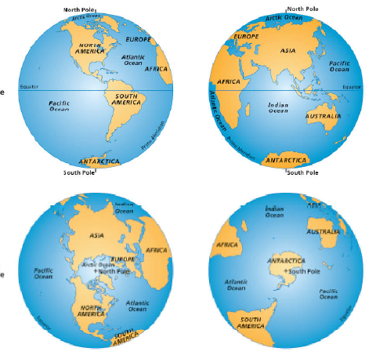  4  2  3  1 | The globes are divided into 4 hemispheres. Label which hemisphere is being shown in each of the 4 pictures.  - _____________________  - _____________________  - _____________________  - _____________________

Label the map. (Ignore the dots!)
- Egypt
- Nile River
- Giza
- Cairo
- Red Sea
- Sinai Peninsula
- Suez Canal
- Mediterranean Sea
- Iraq
- Mesopotamia
- Tigris River
- Euphrates River
- Rift Valley
- Border Cave

