**Location of Egypt**

✂ On the map label & outline in color: Egypt, the equator, prime meridian, Tropic of Cancer & Tropic of Capricorn. Label the oceans. Don’t forget a map key & title. Cut out & glue the map into the INB on page __.

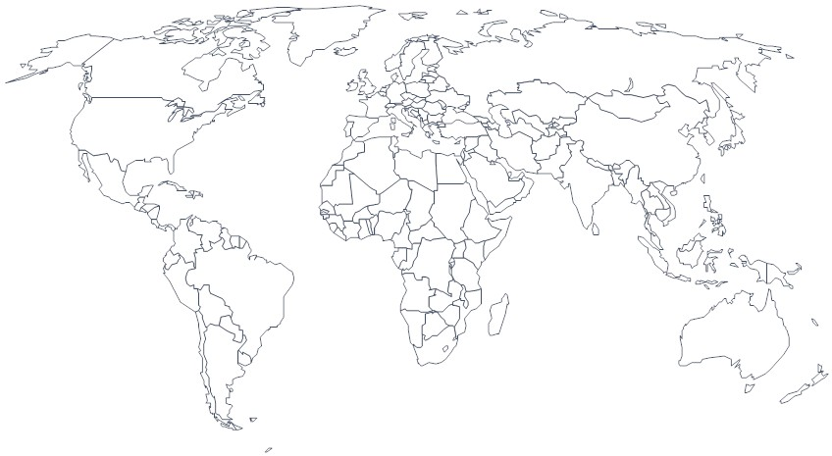

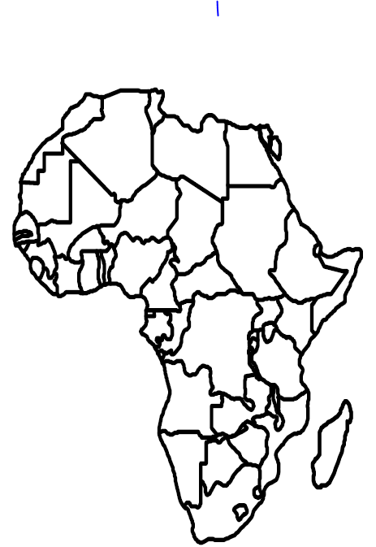

✂ On the map label & outline in color: Egypt, the equator, prime meridian, Tropic of Cancer & Tropic of Capricorn. Label the Atlantic Ocean, the Mediterranean Sea & Red Sea. Don’t forget a map key & title. Cut out & glue the map into the INB on page _____.

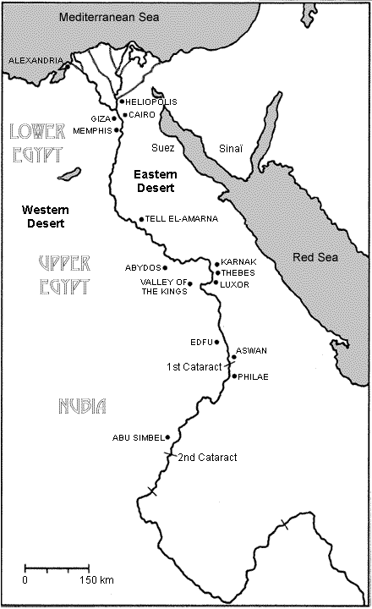

✂ On the map label &/or outline in color:

* Nile River
* Blue Nile River
* White Nile River
* Nile Delta
* Boundary of Ancient Egyptian Civilization
* Great Pyramid
* Valley of the Kings
* Division of Lower &

Upper Egypt

Cut & glue onto INB p. __

1. Make sure you have a key, compass rose & title.
2. In complete sentences tell global position for the Ancient Egyptian civilization.

On page ___ of INB, in complete sentences explain:

1. what the geography of Egypt was like
2. what the climate of Egypt was like& how this climate would have encouraged people to settle in the Nile River Valley
3. Explain what is meant by the phrase, "Gift of the Nile."