Use this map of the Valley of the Kings in your INB page _____. Next to the map write at least 3 conclusions that you can determine from the map & web site | Use this map of the Valley of the Kings in your INB page _____. Next to the map write at least 3 conclusions that you can determine from the map & web site.
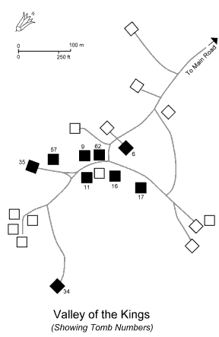
34 Tuthomosis III  35 Amenhotep(Amenophis) II  62 Tutankhamen  57 Horemheb  16 Ramses I  17 Seti I  11 Ramses III  9 Ramses VI  6 Ramses IX  http://www.egypt-tehuti.org/articles/valley-of-kings.html | No: Pharaoh  34 Tuthomosis III  35 Amenhotep(Amenophis) II  62 Tutankhamen  57 Horemheb  16 Ramses I  17 Seti I  11 Ramses III  9 Ramses VI  6 Ramses IX  http://www.egypt-tehuti.org/articles/valley-of-kings.html

http://www.thebanmappingproject.com/

